**Instructions to get ERP Trigger and Logging Up and Running – Bench Unit**

1. Plug in GPS receiver (USB) – female connector (USB extender cable) – mount high above ground and once powered, use “cgps” to test GPS connection status. Keyboard, HDMI monitor and mouse connection show, but not necessary to boot and run. Field unit has only Ethernet, USB extender, and USB power.

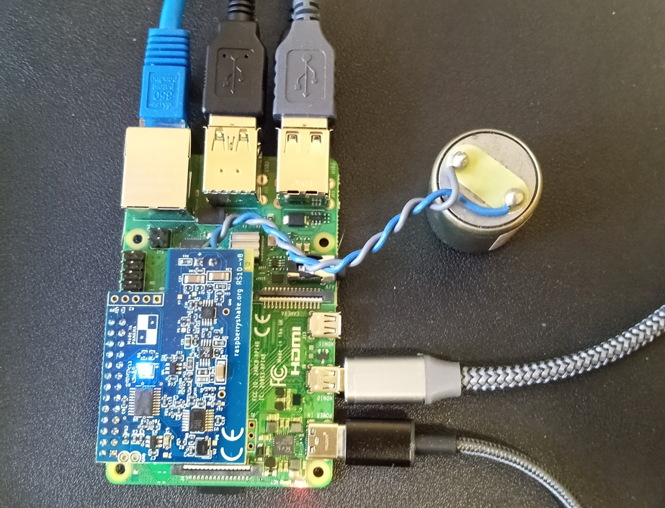

1. Plug in Solar Power unit to power up – male connector (full size) and note that fully charged power bank should have a full complement of blue LEDs lit and the green LED means solar charging is in progress (no power draw indication). With an “ampclamp”, **the current used during boot-up and operation is between 0.5 amps and 1.0 amps (2.5 to 5.0 Watts at 5V). Power does not appear to be an issue as long as solar fully charged.**

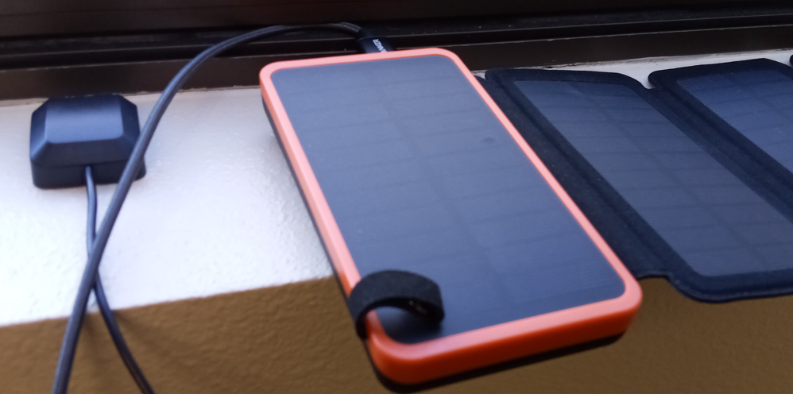

1. Note that the Ethernet should show activity as soon at the Shake gets power (shown below with my USB Ethernet adapter on Windows surface)

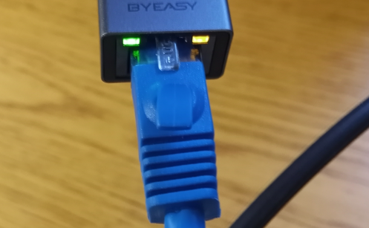

1. On direct connect Ethernet host system (Windows surface), use “ipconfig” to verify assignment of a 192.16.x.x address by Windows.
2. Check status with rs.local web page and ssh to ethernet assigned to Ethernet directly connected device (if windows not that this will disable Wireless without a registry change).

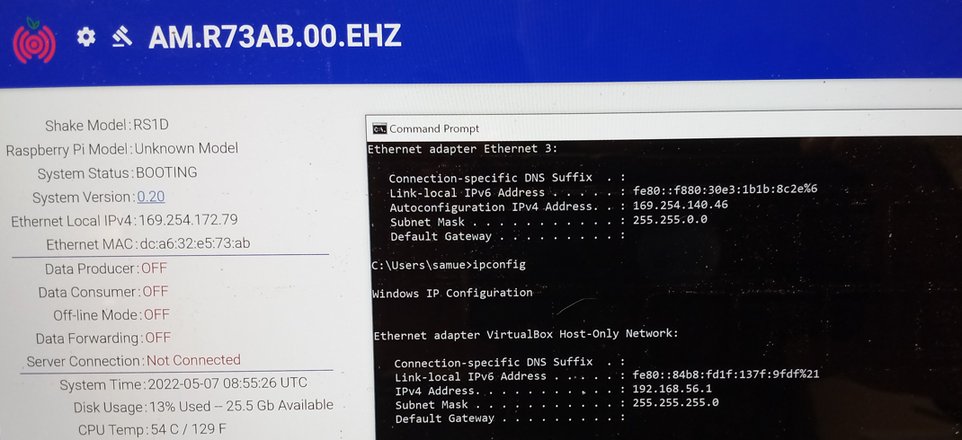

1. In scripts, make executable and run the obspy python script
   1. Optional: Make geophone r-pi an access point in scripts using the access point
   2. Test access point access – SSID will be the STN ID
2. Sudo apt-get install ntpstat (ntpq -p)
3. cat /opt/settings/sys/STN.txt
4. Put the STN into “station” field in main.py – e.g., for this test - **R1C7B**
5. Run main.py
6. Use Helicorder to see recent activity – bottom of rs.local

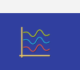

1. Verify trigger and data collection by bench test vibration and check for data collection.
2. Data download - <https://manual.raspberryshake.org/download.html>
   1. **/opt/data/archive**
   2. **sftp -r myshake@<ip_address>:/opt/data/archive /tmp**

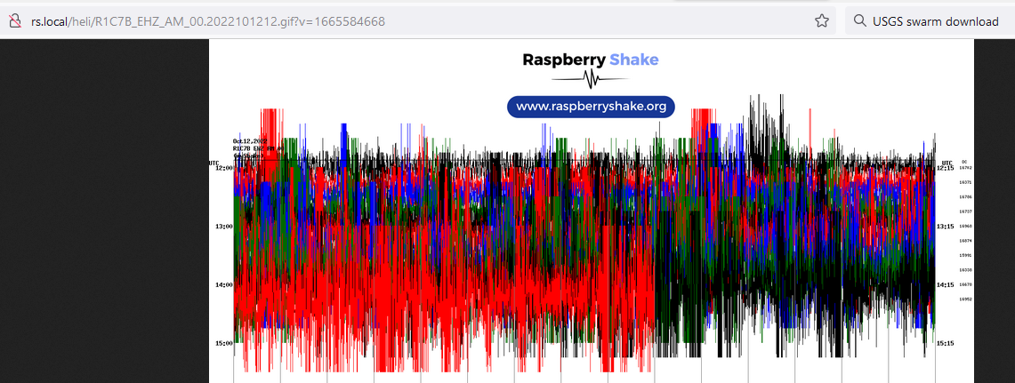

**Testing Pre-deployment – Field Unit**

From prior field research (<https://raspberryshake.org/news/using-seismographs-to-detect-african-elephants/>) – the importance of a vault is noted – “If, in our original experiment, we could have built a small concrete vault for the sensor, we believe we could have detected more signals. Unfortunately, we were limited to temporarily placing the RS&B units inside plastic cases that were buried at a shallow depth into the soft soil of the reserve, which was not ideal. Still, we are confident we can refine these details and that the RS&B can play a genuine role as part of a wider network of sensors for monitoring African elephants in the wild.”

1. Vault construction – cinder blocks, bonded with liquid nails, NEMA enclosure installed inside on wood blocks (perhaps more bracing and packing internally with wood blocks would be good – fill the void), with top cinder block lid (handles for lift). Concern is cracking of cinder block lid in compression, but NEMA is secondary protection and seals unit to keep moisture out.
2. Powered on and rs.local and ssh test done to make sure cables properly installed and shake shack software is operational.

Additional strain relief on cables might be advised – somewhat provided by NEMA and wrap-around configuration, but perhaps zip ties inside the enclosure or other measures would help if there is “cable pull” or other tension put on cables when deployed.

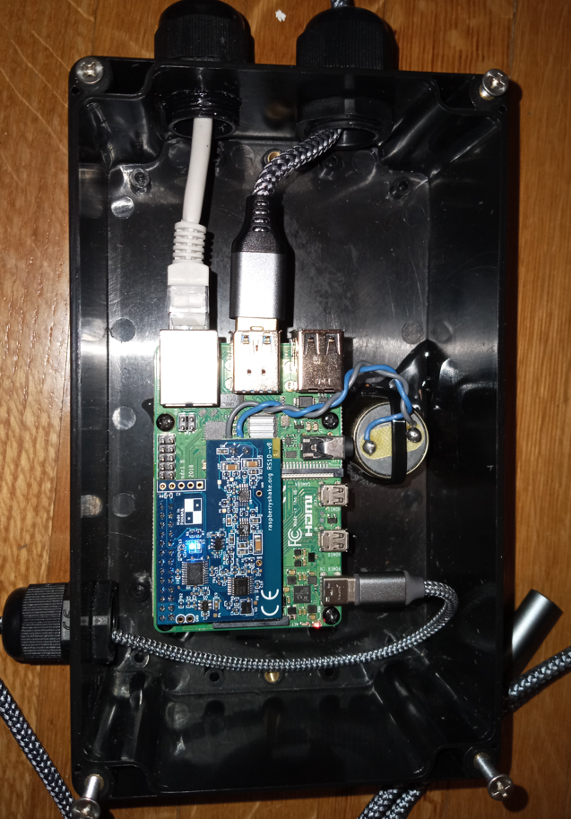 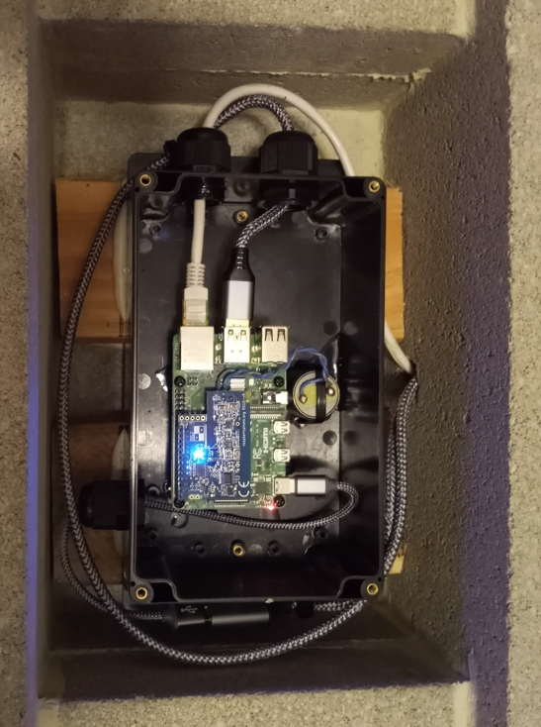 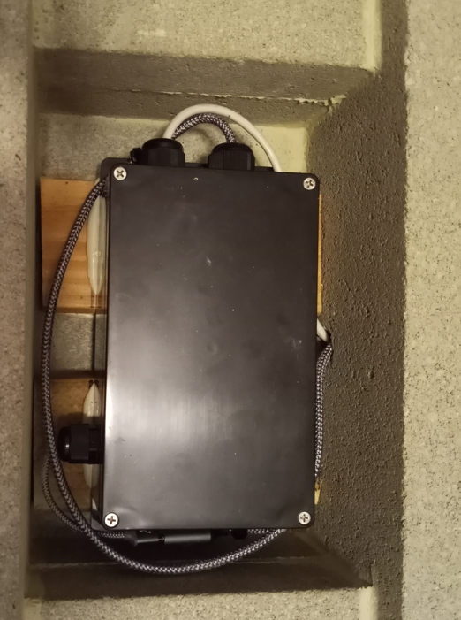

1. Prior to transport the the fram the unit was powered and tested in the vault again before sealing the NEMA enclosure with rs.local, ssh, and power from Solar power bank. Passed all basic tests before transport to the farm to bury.
2. Vault closed (lid is held in place by friction – not glued and not strapped – possible improvement), but assumption is that most force is compression rather than shear. Wrapping the valut with stapping to make sure the lid is less likely to slide out of place might be advised. See the closed vault images below.

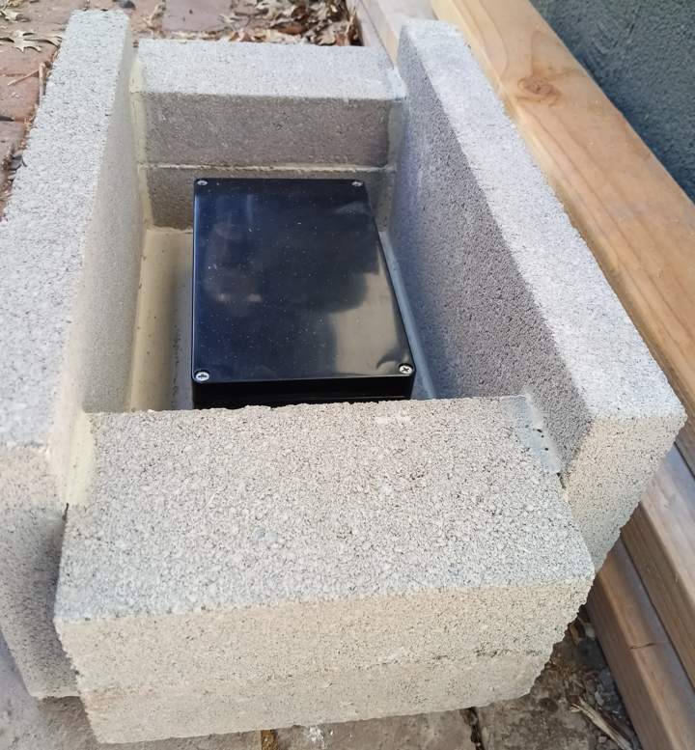 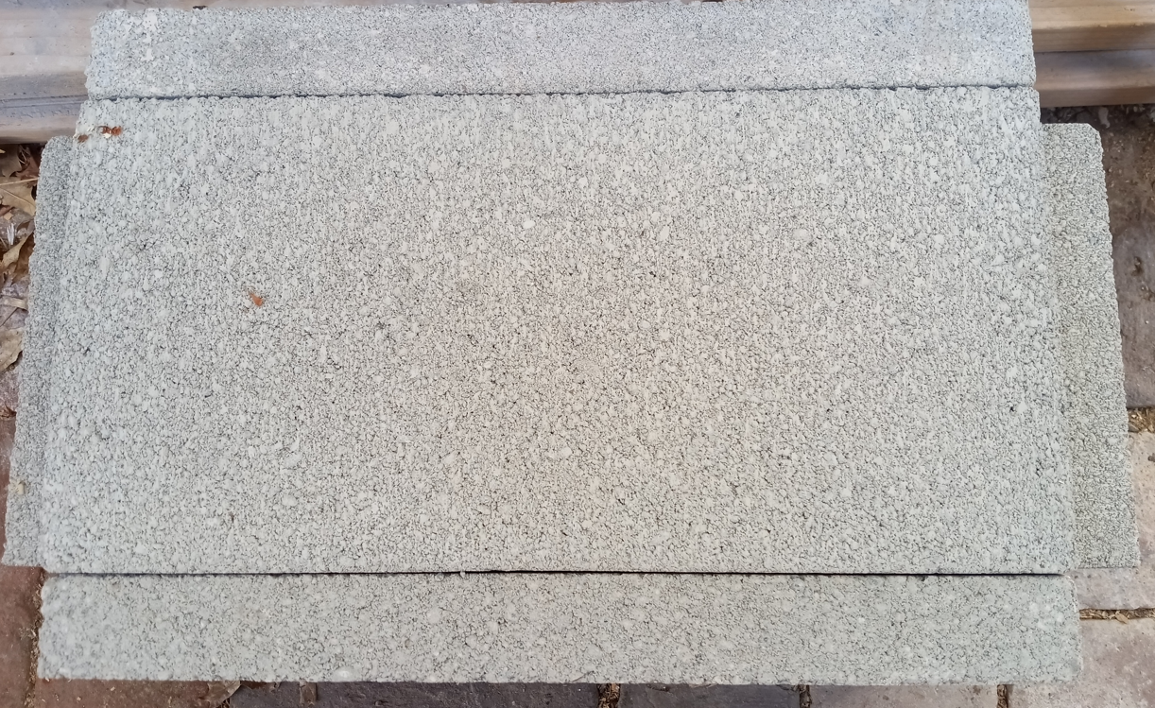 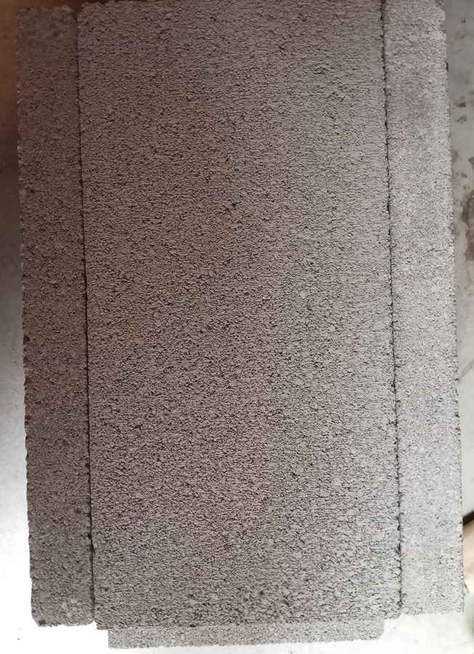

1. Buried inside fence near fence post (for cable run) about 3 feet in depth (top 2 feet below ground), soil mildly compacted with backhoe to be level, cables run outside the fence and ultimately protected with a PVC pipe (post bury). Vault placed on relative flat hole bottom with dirt hand packed around the sides before the backhoe replaced soil on top and compacted.

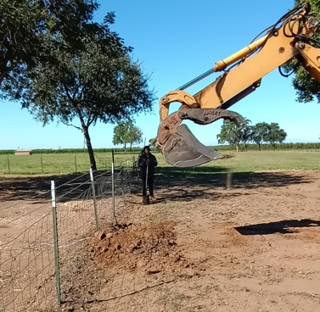 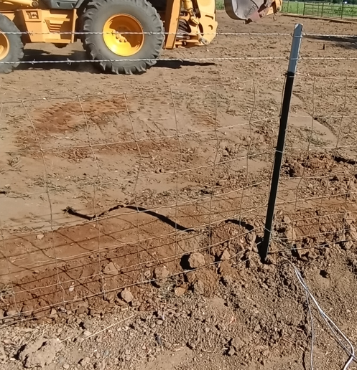

1. Unfortunately, computer and cables required to test immediately post install were not available. First real-power on test was on 10/14/22, almost 2 months later!
2. Power-on test in place on 10/14/22 failed step #3 in bench test procedure – never saw any link lights and could be due to:
   1. Cable pull on power or networking (due to strain during burial or in-place)
   2. Vault structural failure (soil on 10/14/22 was significantly compacted by cows/bulls)
   3. Connector corrosion or dirty connector issues or cable failure
   4. Procedures followed matched bench tests (repeatable), but there is always the potential for error (unlikely)
3. Summary – dig up, inspect for failures, re-deploy. Ideas to improve are:
   1. Deploy outside of fence (other side) – less stress on unit
   2. Reinforce the vault (e.g., interior wood supports)
   3. Re-design the vault
   4. Add better cable strain relief measures
   5. Bench test thoroughly before re-deployment and fix/replace any broken hardware

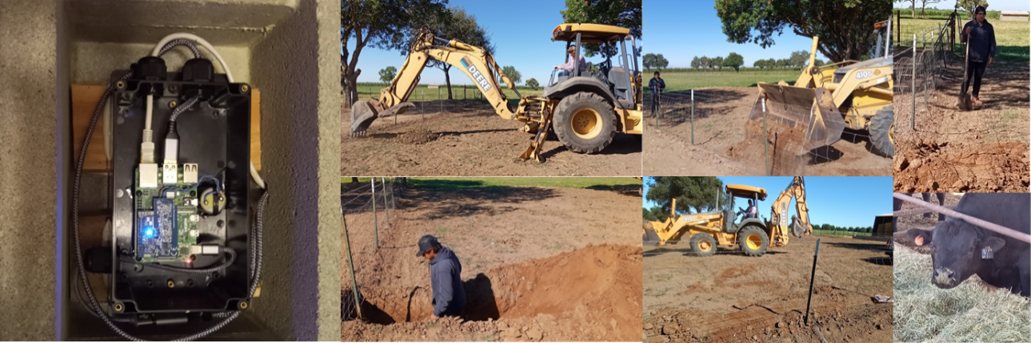

Bench Testing and Network Configuration for Upgrades

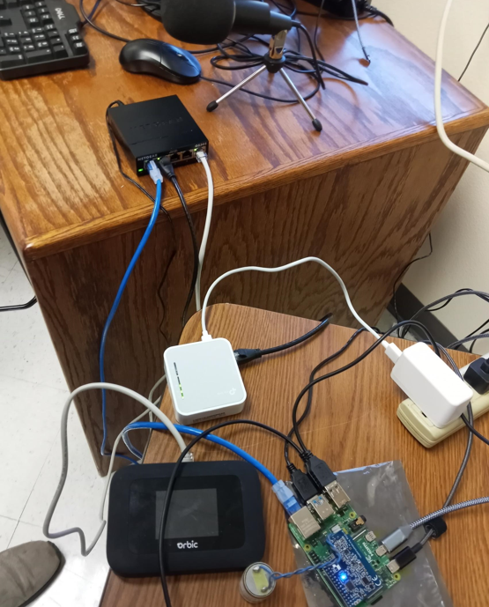

I have the configuration we want up and running on the bench – it’s complex, but it is entirely stand-alone and have the following ideal properties:

1. Windows surface on the Internet and can SSH to R-Pi geophone and no rs.local, but web page is on private address of 192.68.1.164 (as shown on Verizon hot-spot)
2. R-Pi geophone is on the Internet as 192.168.1.164 via 5GUW wired connection via switch, so it can do sudo apt-get install XXX

**Some R-Pi Shake field software update notes**

1. Shake shack updated software on 8/22/22 – Newest is buster, 10 (lsusb_release -a), 5.10.103 (uname -a)
2. Fielded unit was flashed on 8/9/22 – Also buster, 10 (lsusb_release -a), but 4.19.97 (uname -a)
3. R-Pi connected to Internet via switch and 5GUW – 192.168.1.164 IP is being assigned by the Verizon hot-spot (it shows up as “other”)
4. Verizon 5GUW hot-spot– admin is on LCD or 192.168.1.1
5. TP Link travel router connected to switch - admin is 192.168.0.1
6. Windows surface – connected to TP-Link (not Verizon hot-spot!)
7. No use of direct connect to R-Pi geophone – 2 reasons:
   1. Windows disables second wireless (might be fixable, but registry edits have led me nowhere)
   2. Does not allow the R-Pi geophone to be on the Internet at the same time as wireless when wireless is enabled

**Field Test – Connector weathering notes**

1. Ethernet connector is corroding (rain, dew, sun cycle) and connection is intermittently failing (either no link light, or just a solid link light and failure to bring up link).
   1. Replacing RJ45 with new
   2. Use outdoor protector enclosures
2. USB power connector is also corroding, but easily cleaned. Powered off of grid to verify that power is not an issue (300 Watt inverter)